1 - Precision livestock farming in buffalo species: a sustainable approach for the future (Matteo, Neglia)
increasing demand for animal-derived foods requires enhancement in increasing efficiency of farms and production. Precision Livestock Farming (PLF) represents a valuable strategy to tackle challenges in this area. PLF, uses digital technologies like sensors, IoT, AI, and data analytics to monitor and manage individual animals.
PLF technologies have been applied particularly to species such as pigs, poultry and dairy cattle.

2 - Responses of Dairy Buffalo to Heat Stress Conditions and Mitigation Strategies: A Review (Francesca Petrocchi Jasinski)
A value of THI < 72 is considered optimal, THI between 72 to 79 is considered as mild stress, 80–89 is considered as moderate stress, and ≥90 is considered as severe stress in buffalo

All the references [27,39–48] agree that there was an increase in respiratory rate (RR) with the increase in THI. So, RR seems to be the easiest and cheapest marker to evaluate HS levels.

Heat Stress Reduces Yield:
The primary mechanism for this loss is a voluntary reduction in Dry Matter Intake (DMI) . Animals eat less to lower the metabolic heat produced by digestion, which directly limits the energy available for milk production.

Cold Stress Sensitivity: A surprising finding highlighted in the review is that Italian Mediterranean buffaloes appear more susceptible to low temperatures than to heat.
One study cited (Matera et al., 2022) observed that milk yield declined when THI fell below 59 but remained stable when THI was above 60.

Another study (Zicarelli, 2021) reported that a higher percentage of animals decreased milk production during the coldest seasons (41.22%) compared to the hottest seasons (29.91%)

3 - The role of age at first calving in shaping production and reproductive outcomes in Italian buffaloes (Matteo, Neglia)
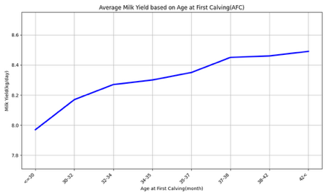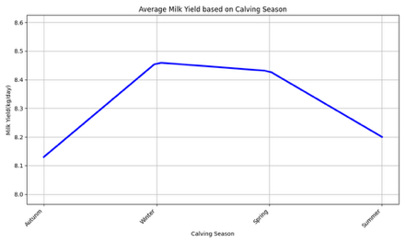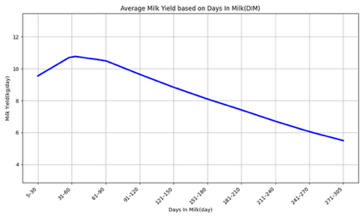

4 - The cost of being early or late: Biological and economic outcomes of age at first calving in dairy buffaloes (Matteo, Neglia)
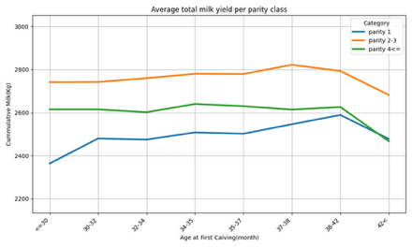
5 - Estimating performances of dairy buffaloes in a new model of automated milking system (Neglia)
to evaluate for the first time the efficiency of new AMS models in buffaloes using a large dataset, focusing on milk quantity and quality traits,
currently only four buffalo farms in Italy are equipped with AMS. Previous studies on buffaloes indicate that AMS improves the productive performance of Italian Mediterranean buffaloes in both quantitative and qualitative

unlike dairy cows, buffaloes have been described to be very sensitive to environmental and milking routine changes

higher values during the first days in milk, followed by a decrease throughout lactation, correlating with decreased milk production. Higher average milk flow rates were observed in multiparous buffaloes
multiparous animals having higher milk yield (MY) and energy-corrected milk (ECM).

6 - Milk characteristics and milking efficiency in Italian Mediterranean buffalo (Neglia)
Nothing useful.

7 - Characterization of milk ejection dynamics in dairy buffaloes based on Lactocorder® measurements (Matteo, Neglia)
Nothing useful.

8 - Exploring the sources of variation of electrical conductivity and total and differential somatic cell count in Italian Mediterranean buffaloes (Neglia)
Climatic information (i.e., temperature at 2 m [T, °C] and relative humidity at 2 m [RH, %]) were retrieved from the NASA Power.
conversion of temperature degrees from Celsius to Fahrenheit, given that most of the literature is based on temperature values measured on a Fahrenheit scale.
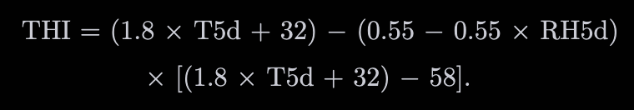
9 - Genetic parameters for somatic cell score, differential somatic cell count, and milk electrical conductivity in dairy buffaloes (Neglia)
Nothing useful, they used Nasa Power

10 - Exploiting machine learning methods with monthly routine milk recording data and climatic information to predict subclinical mastitis in Italian Mediterranean buffaloes (Bobbo, Neglia)
They using R Lang.
Prediction models were developed using 4 different ML algorithms (Generalized Linear Model, Support Vector Machines, Random Forest, and Neural Network)
Support Vector Machine was the best method to predict high or low somatic cell count
Neural Network was the best method for making predictions on the test set.
To prevent overfitting, two approaches used for splitting data, first splitting by records, second splitting by animal id

Recursive feature elimination:
They applied 10-fold cross validation for 100 times and then collect the most important features and removed the rest features and again applied the10-fold cross validation for 100 times on the most important features for training
Metrics:
Accuracy, AUC, MCC, F1 Score, Kappa of CV.

11 - 137. Machine learning to predict somatic cell count at the subsequent test-day record in the Italian Mediterranean Buffaloes (Neglia, Bobbo)
This is the same as previous one.

12 –
13 –
14 - An AI-Driven Multimodal Monitoring System for Early Mastitis Indicators in Italian Mediterranean Buffalo (Neglia)
Unrelated.

15 - Development and Validation of a Multi-Source Edge–Cloud IoT-Based Decision Support System for Real-Time Cold Stress Detection and Management in Dairy Buffalo Farming (Matteo, Neglia)

while heat stress is widely studied, cold stress is often neglected, particularly for the Mediterranean buffalo.
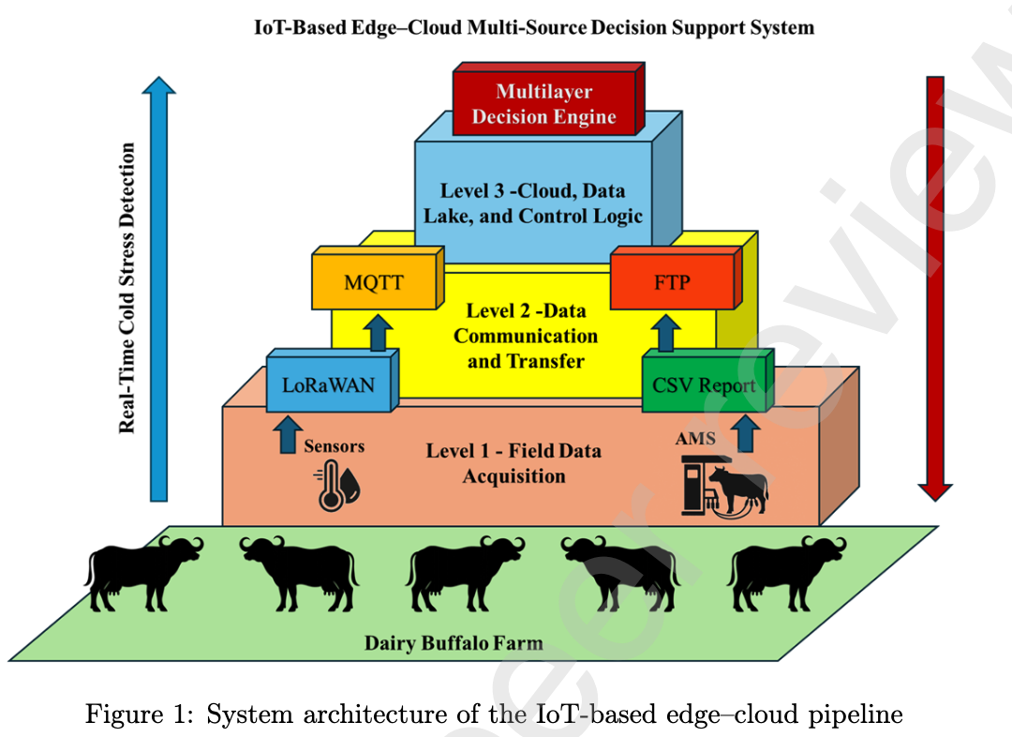

Level 1: Field Data Acquisition (The Hardware)
They integrated two distinct data sources:
- Automated Milking System (AMS): they collect data from AMS.
- IoT Weather Station: they collect weather data using IoT sensors like temperature, relative humidity, wind speed, and atmospheric pressure.

Level 2: Data Communication (The Transfer)
They implemented a hybrid communication infrastructure:
- For Environmental Data: they used LoRaWAN to send data to the cloud.
- For Production Data: Used daily batch transfers via secure protocols (FTP).

Level 3: Cloud & Logic (The Processing)
- Data Lake: they used a time-series database (InfluxDB) to to store data
- Fusion Algorithm: Developed a Python-based function to link AWS data with weather data occurring at that exact time.
Cold–Humidity Index(CHI) for cold conditions
Wind Chill Index (WHI)
Daily Thermal Variation (∆Tmax)

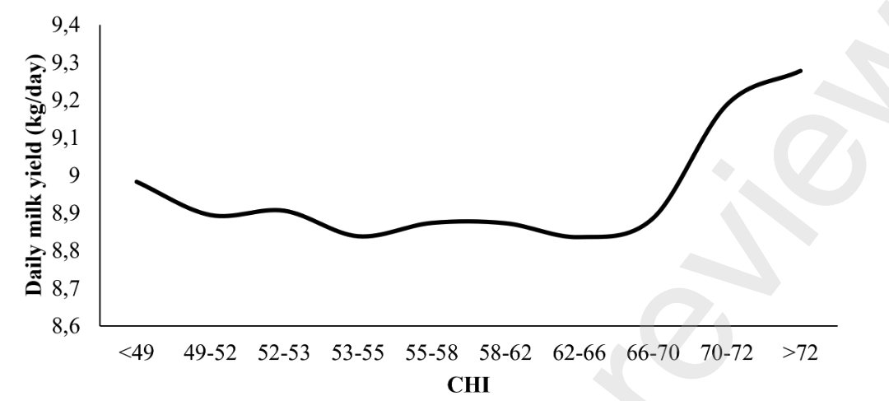
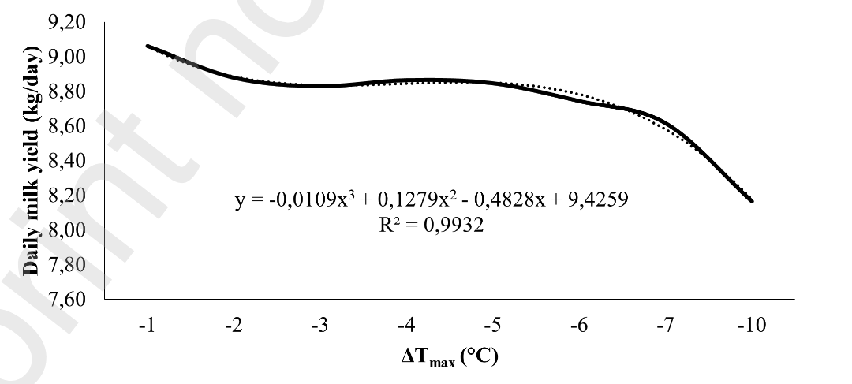

16 - Comparison of K-Means and Hierarchical Clustering Methods for Buffalo Milk Production Data (Matteo)
Nothing useful.
17 –
Nothing useful
18 –
Nothing.

